Middle Country Central School District
Health Services
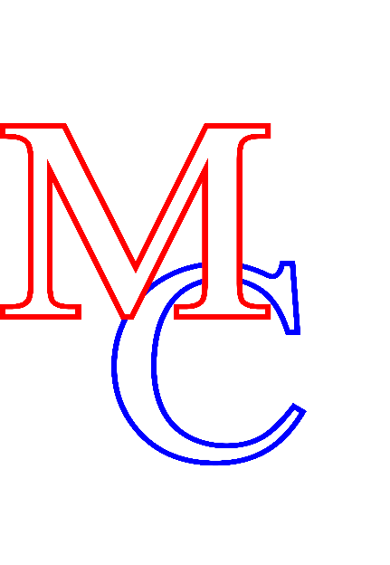
8 43rd Street ∙ Centereach, NY 11720
631-285-8650 ∙ 631-285-8151 (fax) ∙ www.mccsd.net

Roberta A. Gerold, Ed.D., Superintendent of Schools
Francine McMahon, Deputy Superintendent for Instruction
Beth Rella, Ed.D., Assistant Superintendent for Business
James G. Donovan, Assistant Superintendent for Human Resources
Joseph Mercado, Director of Physical Education, Health and Athletics

Dear Parent or Guardian, Date: __________

Health care provider and parent permission is needed for all prescription and over the counter (OTC) medications used at school or school-sponsored activities.
- Parents/guardians are responsible for having medications delivered directly to the school in a properly labeled original container by an adult, unless student has a health care provider attestation to carry and use their medication independently (see below).
- Please bring all medication directly to the school health office.
- If your child’s health care provider decides your child can carry and use their diabetes, asthma or epinephrine auto-injector medication independently and you wish them to do so, they must put in writing (attest) that your child can do so safely. We have a form they can use to provide this information if they wish.
- Please provide emergency action plan from physician in the event of life threatening allergies
- Please ask the pharmacist to give you a labeled container for prescription medications so we can send this bottle on field trips.
- Sending small containers of any OTC medications makes it easier to send the correct amount needed on field trips and comply with New York State laws pertaining to medication storage.
Medication forms are available on our district web site or may be obtained from the School Health Office. Your physician may use their own form if desired.
We will be available for medication drop off through school hours on:
Tuesday, September 5th, 2023.
If you need to make special arrangements to drop off medication, please call to make these arrangements.

Thank you in advance for your cooperation

School Nurse: Mrs. Cheryl Capek & Mr. George Sheehan

Phone: 631-285-8920 Fax: 631-285-8901

Email: ccapek@mccsd.net
Email: gsheehan@mccsd.net

